Assignment MySQL

**Table 1: SalesPeople**

**Snum**is Primary key

**Sname**is Unique constraint

**Snum Sname City Comm**

**1001** Peel. London .12

1002 Serres Sanjose .13

1004 Motika London .11

1007 Rifkin Barcelona .15

1003 Axelrod Newyork .10

**Syntax:**

CREATE TABLE salespeople (

Snum INT PRIMARY KEY,

Sname VARCHAR(30) UNIQUE ,

City VARCHAR(30),

Comm INT

);

insert into Customers values (2001, 'Hoffman', 'London', 1001);

insert into Customers values (2002, 'Giovanni', 'Rome', 1003);

insert into Customers values (2003, 'Liu', 'Sanjose', 1002);

insert into Customers values (2004, 'Grass', 'Berlin', 1002);

insert into Customers values (2006, 'Clemens', 'London', 1001);

insert into Customers values (2008, 'Cisneros', 'Sanjose', 1007);

insert into Customers values (2007, 'Pereira ', 'Rome', 1004);

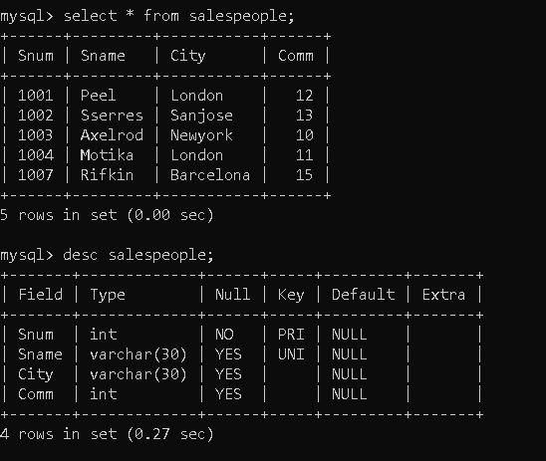

**Table 2: Customers**

**Cnum**is Primary Key

**City**has not null constraint .

**Snum is foreign key constraint refers Snum column of SalesPeople table.**

Cnum Cname City Snum

2001 Hoffman London 1001

2002 Giovanni Rome 1003

2003 Liu Sanjose 1002

2004 Grass Berlin 1002

2006 Clemens London 1001

2008 Cisneros Sanjose 1007

2007 Pereira Rome 1004

**Syntax:**

Create Table Customers(Cnum INT PRIMAY KEY,

Cname VARCHAR(30),

City VARCHAR(30) NOT NULL,

Snum INT,

FOREIGN KEY (Snum) REFERENCES Salespeople(Snum)

);

insert into Customers values (2001, 'Hoffman', 'London', 1001);

insert into Customers values (2002, 'Giovanni', 'Rome', 1003);

insert into Customers values (2003, 'Liu', 'Sanjose', 1002);

insert into Customers values (2004, 'Grass', 'Berlin', 1002);

insert into Customers values (2006, 'Clemens', 'London', 1001);

insert into Customers values (2008, 'Cisneros', 'Sanjose', 1007);

insert into Customers values (2007, 'Pereira ', 'Rome', 1004);

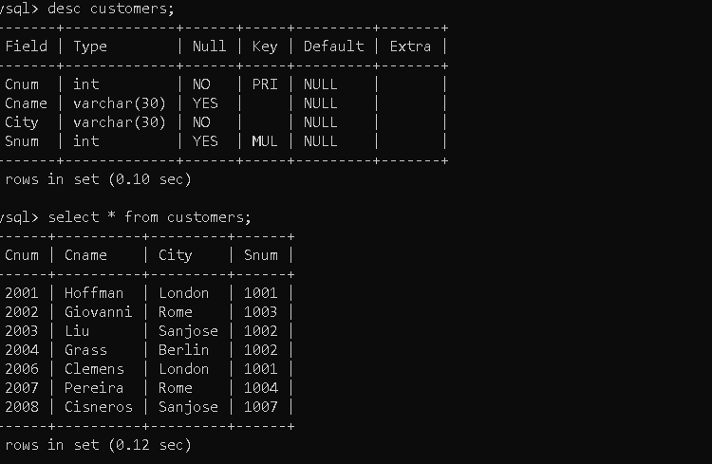

**Table 3: Orders**

**Onum** is Primary key

**Cnum is foreign key refers to Cnum column of Customers table. Snum is foreign key refers Snum column of SalesPeople table.**

Onum Amt Odate Cnum Snum

3001 18.69 3-10-1990 2008 1007

3003 767.19 3-10-1990 2001 1001

3002 1900.10 3-10-1990 2007 1004

3005 5160.45 3-10-1990 2003 1002

3006 1098.16 3-10-1990 2008 1007

3009 1713.23 4-10-1990 2002 1003

3007 75.75 4-10-1990 2004 1002

3008 4273.00 5-10-1990 2006 1001

3010 1309.95 6-10-1990 2004 1002

3011 9891.88 6-10-1990 2006 1001

**Syntax:**

CREATE TABLE orders (

Onum INT PRIMARY KEY,

Amt decimal(6,2),

Odate VARCHAR(10) NOT NULL,

Cnum INT NOT NULL,

Snum INT NOT NULL,

FOREIGN KEY (Cnum) REFERENCES Customers(Cnum),

FOREIGN KEY (Snum) REFERENCES Salespeople(Snum)

);

insert into Orders values (3001, 18.69, '1990-10-3', 2008, 1007);

insert into Orders values (3003, 767.19, '1990-10-3', 2001, 1001);

insert into Orders values (3002, 1900.10, '1990-10-3', 2007, 1004);

insert into Orders values (3005, 5160.45, '1990-10-3', 2003, 1002);

insert into Orders values (3006, 1098.16, '1990-10-3', 2008, 1007);

insert into Orders values (3009, 1713.23, '1990-10-4', 2002, 1003);

insert into Orders values (3007, 75.75, '1990-10-4', 2004, 1002);

insert into Orders values (3008, 4273.00, '1990-10-5', 2006, 1001);

insert into Orders values (3010, 1309.95, '1990-10-6', 2004, 1002);

insert into Orders values (3011, 9891.88, '1990-10-6', 2006, 1001);

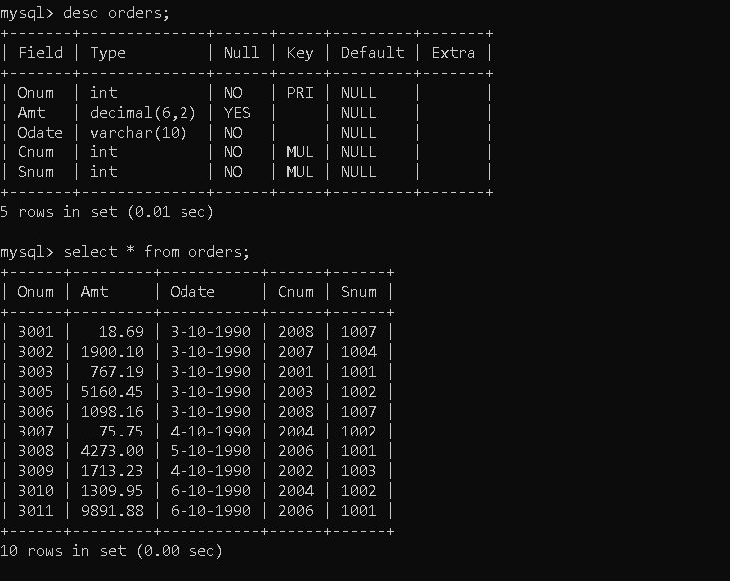

On the basis of above tables specific tasks has been performed according to the questions:

1. Count the number of Salesperson whose name begin with ‘a’/’A’.

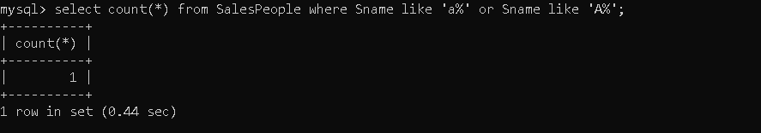

1. Display all the Salesperson whose all orders worth is more than Rs. 2000.

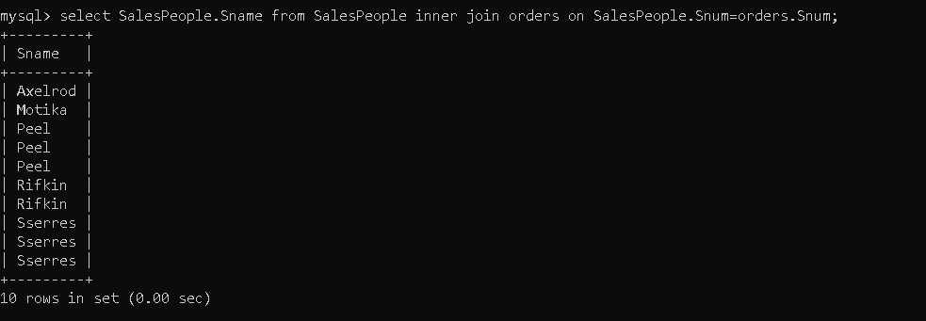

1. Count the number of Salesperson belonging to Newyork.

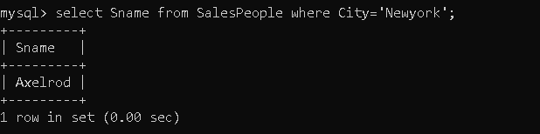

1. Display the number of Salespeople belonging to London and belonging to Paris.

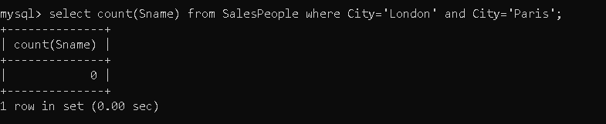

1. Display the number of orders taken by each Salesperson and their date of orders.

